Volatility correlation: NZDUSD and EURGBP
Method 25 / daily |log returns| / rho_vol / Alpari D1 full available history (realized deferred)

Study setup
Logical pair: NZDUSD , EURGBP
Broker symbols: NZDUSD_i , EURGBP_i
Snapshot: 2026-11-03_majors_alpari_D1
Timeframe: D1
Matched return window: 1999-01-06 to 2026-11-02 (UTC bar dates)
Matched return count n: 7183
Dropped unfinished last bar dated 2026-11-03 UTC after a tick-volume check against the prior complete day.
Statistic: rho_vol = Corr(|log return_L|, |log return_R|)
rho_realized: not computed (no intraday buckets in this snapshot)
Complete matched rows (Excel): NZDUSD-EURGBP_Vol_D1.xlsx
Complete matched rows (HTML table): NZDUSD-EURGBP_Vol_D1_data.html

Method carried forward
Volatility correlation rho_vol = Corr(|x_t|, |y_t|) measures whether absolute daily log returns of close move together in size, regardless of sign. Quotes are not inverted. Same-sample signed Pearson r is a side check. The formula sheet also defines within-day realized correlation rho_realized,d from intraday buckets; this v001 uses the Alpari D1 snapshot only, so rho_realized is not computed (no intraday buckets). This is not causation and not a trading signal.

Results (headline)
rho_vol: 0.206626
Pearson r (signed): 0.037186
mean |NZDUSD|: 0.00567189
mean |EURGBP|: 0.00353836
rho_realized: n/a (D1-only snapshot)

Conclusion
Headline rho_vol for NZDUSD and EURGBP: 0.2066. Signed Pearson r = 0.0372. Mean |return|: 0.005672 (NZDUSD), 0.003538 (EURGBP). rho_realized not computed (D1 snapshot has no intraday buckets). This is absolute-move co-movement, not a trading signal.

Charts
Daily closes

Daily log returns

Absolute returns scatter
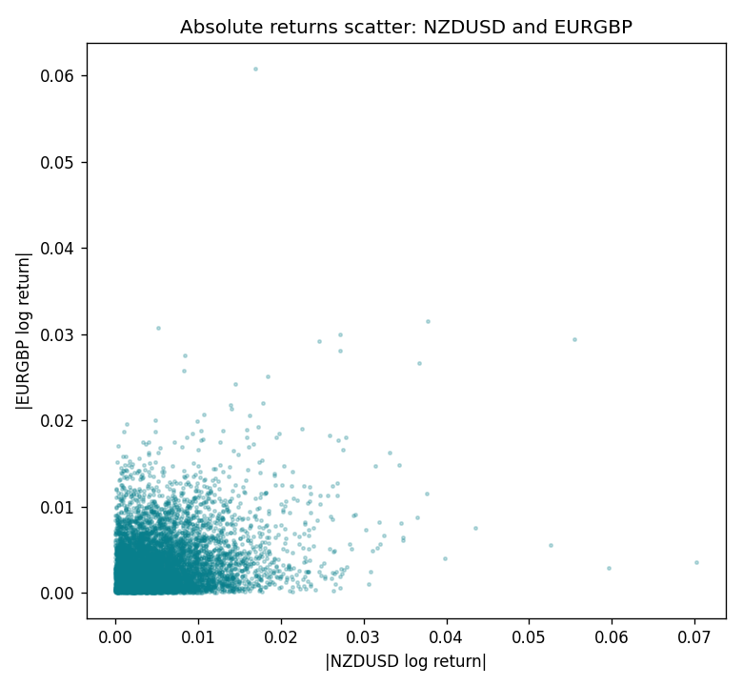

Data report
Matched rows are in the sibling Excel workbook named NZDUSD-EURGBP_Vol_D1.xlsx. Embedding all rows as a Word table is impractical; this file holds column summaries and the first and last 15 matched rows.
Columns: time, NZDUSD_open, EURGBP_open, NZDUSD_high, EURGBP_high, NZDUSD_low, EURGBP_low, NZDUSD_close, EURGBP_close, NZDUSD_tick_volume, EURGBP_tick_volume, NZDUSD_spread, EURGBP_spread, NZDUSD_real_volume, EURGBP_real_volume, NZDUSD_log_return, EURGBP_log_return, NZDUSD_abs_return, EURGBP_abs_return
Column summaries (matched calculation rows)
column | count | mean | std | min | 25% | 50% | 75% | max
NZDUSD_open | 7183 | 0.65646991 | 0.10818219 | 0.3913 | 0.591455 | 0.6684 | 0.72495 | 0.88218
EURGBP_open | 7183 | 0.78694248 | 0.0966971 | 0.5734 | 0.68755 | 0.83389 | 0.86522 | 0.9769
NZDUSD_high | 7183 | 0.66038812 | 0.10867344 | 0.3961 | 0.5949 | 0.67204 | 0.729365 | 0.88421
EURGBP_high | 7183 | 0.7900202 | 0.09707133 | 0.5789 | 0.6896 | 0.8369 | 0.8681 | 0.9799
NZDUSD_low | 7183 | 0.65278196 | 0.10777661 | 0.3897 | 0.58816 | 0.6642 | 0.720985 | 0.87988
EURGBP_low | 7183 | 0.78424251 | 0.0965143 | 0.5682 | 0.6855 | 0.83166 | 0.86287 | 0.9661
NZDUSD_close | 7183 | 0.65654354 | 0.10817679 | 0.3907 | 0.59181 | 0.6685 | 0.72502 | 0.8822
EURGBP_close | 7183 | 0.78698724 | 0.09669475 | 0.5735 | 0.68775 | 0.83395 | 0.86536 | 0.977
NZDUSD_tick_volume | 7183 | 68736.568 | 123152.54 | 16 | 5594.5 | 33901 | 58513.5 | 1127682
EURGBP_tick_volume | 7183 | 87133.158 | 145499.84 | 154 | 6553 | 44358 | 81413 | 1424684
NZDUSD_spread | 7183 | 30.260755 | 25.633067 | 0 | 9 | 17 | 40 | 80
EURGBP_spread | 7183 | 21.328832 | 19.122264 | 0 | 4 | 13 | 40 | 50
NZDUSD_real_volume | 7183 | 1.6708354e+10 | 8.49951e+10 | 0 | 0 | 0 | 0 | 2.705649e+12
EURGBP_real_volume | 7183 | 2.7872287e+10 | 1.3521454e+11 | 0 | 0 | 0 | 0 | 3.5726265e+12
NZDUSD_log_return | 7183 | 1.073e-05 | 0.0076464 | -0.07027433 | -0.00425909 | 0.00022967 | 0.00458236 | 0.05966839
EURGBP_log_return | 7183 | 2.33e-05 | 0.00487088 | -0.03067367 | -0.00262163 | -9.879e-05 | 0.002558 | 0.06075387
NZDUSD_abs_return | 7183 | 0.00567189 | 0.00512764 | 0 | 0.00203799 | 0.00444555 | 0.00777945 | 0.07027433
EURGBP_abs_return | 7183 | 0.00353836 | 0.00334728 | 0 | 0.00119473 | 0.00259934 | 0.00485348 | 0.06075387
First 15 matched rows (selected columns)
time | NZDUSD_log_return | EURGBP_log_return | NZDUSD_abs_return | EURGBP_abs_return
1999-01-06 | 0.0020455609 | -0.013303338 | 0.0020455609 | 0.013303338
1999-01-07 | 0.0062963171 | 0.011051402 | 0.0062963171 | 0.011051402
1999-01-08 | -0.00055396548 | -0.004943862 | 0.00055396548 | 0.004943862
1999-01-11 | 0.010290425 | -0.0012752393 | 0.010290425 | 0.0012752393
1999-01-12 | -0.0053157489 | 0.0033970309 | 0.0053157489 | 0.0033970309
1999-01-13 | -0.0099742238 | 0.00042381861 | 0.0099742238 | 0.00042381861
1999-01-14 | -0.00018564931 | -0.0019793588 | 0.00018564931 | 0.0019793588
1999-01-15 | -0.00074294208 | -0.0076715819 | 0.00074294208 | 0.0076715819
1999-01-18 | -0.0018597736 | 0.00071280921 | 0.0018597736 | 0.00071280921
1999-01-19 | 0.0018597736 | -0.0014261269 | 0.0018597736 | 0.0014261269
1999-01-20 | 0.0040793678 | 0.0019960086 | 0.0040793678 | 0.0019960086
1999-01-21 | 0.0040627941 | -0.00071240297 | 0.0040627941 | 0.00071240297
1999-01-22 | -0.012051689 | -0.0017118406 | 0.012051689 | 0.0017118406
1999-01-25 | -0.0035504102 | -0.0054402425 | 0.0035504102 | 0.0054402425
1999-01-26 | 0.0072741158 | -0.00057438255 | 0.0072741158 | 0.00057438255
Last 15 matched rows (selected columns)
time | NZDUSD_log_return | EURGBP_log_return | NZDUSD_abs_return | EURGBP_abs_return
2026-10-13 | 0.0047326165 | 0.00020130374 | 0.0047326165 | 0.00020130374
2026-10-14 | -0.0037306483 | 0.0011241873 | 0.0037306483 | 0.0011241873
2026-10-15 | 0.0047634855 | -0.00087557391 | 0.0047634855 | 0.00087557391
2026-10-16 | 0.0057501001 | -0.0020380844 | 0.0057501001 | 0.0020380844
2026-10-19 | 0.0018917133 | -0.00056950988 | 0.0018917133 | 0.00056950988
2026-10-20 | 0.0037199341 | -0.0035906254 | 0.0037199341 | 0.0035906254
2026-10-21 | 0.0030923331 | -0.00140647 | 0.0030923331 | 0.00140647
2026-10-22 | -0.0033035227 | -0.0018743924 | 0.0033035227 | 0.0018743924
2026-10-23 | 0.0030929853 | 0.00082421033 | 0.0030929853 | 0.00082421033
2026-10-26 | -0.0028993932 | 0.00013133309 | 0.0028993932 | 0.00013133309
2026-10-27 | -0.00026399852 | -0.0019957343 | 0.00026399852 | 0.0019957343
2026-10-28 | -0.0097283914 | 0.00066967224 | 0.0097283914 | 0.00066967224
2026-10-29 | 0.00062190714 | -0.0011722209 | 0.00062190714 | 0.0011722209
2026-10-30 | 0.00019537668 | -0.0024205543 | 0.00019537668 | 0.0024205543
2026-11-02 | -0.0025962955 | 0.00089940465 | 0.0025962955 | 0.00089940465

